BIOS AND HEADSHOTS
Technological Convergence and Regulatory Power

Angie Kronenberg - Chief Advocate and General Counsel, INCOMPAS



Angie joined INCOMPAS in 2013 as its chief advocate and general counsel, managing the INCOMPAS policy team and its work before the federal government. FierceTelecom named Angie a "Rising Star in Wireline" in 2014 and one of the Top Women in Wireline in 2015 for her advocacy work on behalf of INCOMPAS members. Angie is a member of the Federal Communications Bar Association and has been involved in its leadership as a former Executive Committee and Nominations Committee member.

Before joining INCOMPAS, Angie was legal advisor to FCC Commissioner Mignon Clyburn, where she was primarily responsible for the Commissioner’s wireline and broadband agenda, including the Commissioner’s work as chair of three federal-state joint boards. Prior to that, Angie was a special counsel in the Spectrum and Competition Policy Division of the FCC’s Wireless Telecommunications Bureau. She also practiced telecommunications and media law in the Washington, D.C. office of Willkie Farr & Gallagher LLP for more than a decade. Angie earned a Juris Doctor, magna cum laude, from the Columbus School of Law at The Catholic University of America, where she also earned a certification from The Institute for Communications Law Studies, and she earned a Bachelor of Arts degree, magna cum laude, from Baylor University and was elected to Phi Beta Kappa.

Tejas Narechania - University of California, Berkeley, School of Law
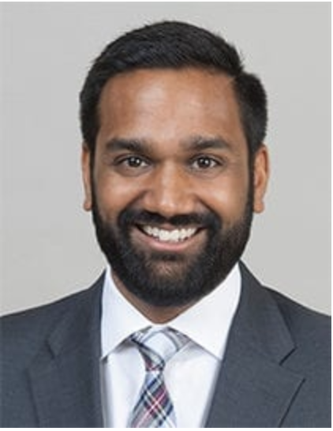
Tejas N. Narechania is the Robert and Nanci Corson Assistant Professor of Law at the University of California, Berkeley, School of Law, where he writes about (and teaches courses on) telecommunications regulation and intellectual property, among other subjects. He is also a Faculty Co-Director of the Berkeley Center for Law & Technology.
Before joining Berkeley Law, Professor Narechania clerked for Justice Stephen G. Breyer of the Supreme Court of the United States (2015–2016) and for Judge Diane P. Wood of the U.S. Court of Appeals for the Seventh Circuit (2011–2012). He has advised the Federal Communications Commission on network neutrality matters, where he served as Special Counsel (2012–2013). He has a J.D. from Columbia Law School, where he received the Ruth Bader Ginsburg Prize and was the Executive Notes Editor of the Columbia Law Review. He also has a B.S. (Electrical Engineering and Computer Science) and a B.A. (Political Science) from the University of California, Berkeley.
Professor Narechania’s research projects have appeared in the Columbia Law Review, the Georgetown Law Journal, the Michigan Law Review, the Stanford Law Review Online, and the Washington Law Review, among other outlets. His projects have been cited and discussed in the courts and the media, including in the work of the Supreme Court and the U.S. Court of Appeals for the Federal Circuit, as well as in the New York Times and the Washington Post, among other venues.

Jon Nuechterlein - Sidley Austin LLP

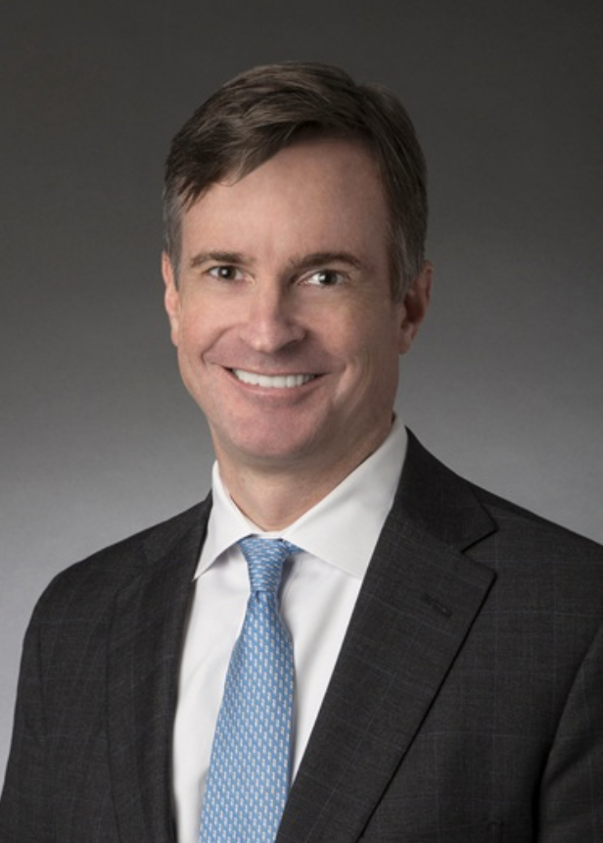
Jon Nuechterlein, a partner and co-leader of Sidley’s Telecom and Internet Competition practice, focuses on telecommunications law, antitrust, and appellate litigation. He rejoined the firm in 2016 after serving as General Counsel of the Federal Trade Commission. Jon’s extensive government experience also includes positions as Deputy General Counsel of the Federal Communications Commission, as Assistant to the Solicitor General, and as law clerk to D.C. Circuit Judge Stephen Williams and Supreme Court Justice David Souter. He is the author (with Phil Weiser) of a widely cited treatise on telecommunications law and policy.
Since rejoining Sidley in 2016, Jon has advised clients on a range of regulatory and appellate matters, including:
- Presented argument in the D.C. Circuit on behalf of all major ISP trade associations on appeal of the FCC’s net neutrality rules (Mozilla Corp. v. FCC, 940 F.3d 1 (D.C. Cir. 2019))
- Briefed and argued appeal on behalf of a telecom industry group in support of the FCC’s new competition regime for business data services (Citizens Telecomms. Co. of Minn. v. FCC, 901 F.3d 991 (8th Cir. 2018))
- Represented AT&T on appeal in defense of its $85 billion merger with Time Warner (United States v. AT&T, Inc., 916 F.3d 1029 (D.C. Cir. 2019))
- Advising tech companies in connection with FTC and DOJ antitrust investigations
- Representing a major ISP in connection with the FTC’s investigation into broadband industry privacy practices
The Best Lawyers in America named Jon as the 2019 “Lawyer of the Year” for Communications Law in Washington, D.C. The publication quotes clients who describe him as “incredibly smart” and “an excellent writer and oral advocate, particularly when it comes to taking complex legal, economic, and technical concepts and translating them into plain English.” Jon is also listed in Band 1 for Telecom, Broadcast and Satellite in Chambers USA: America’s Leading Lawyers for Business (2017, 2018, and 2019). Chambers quoted one client as remarking: “He is one of the best telecom attorneys in the industry. He is truly one of the smartest people I have ever met, and brings a fresh and well-reasoned perspective to knotty issues.” In January 2020, Law360 named Jon and his Sidley colleagues “Telecommunications Group of the Year,” citing their “high-profile court victories in closely watched telecom cases over the last year.”

Howard Shelanski - Georgetown University Law Center



Howard Shelanski earned his B.A. from Haverford College and received his J.D. and Ph.D. in economics from the University of California at Berkeley. After graduating from law school he clerked for Judge Stephen F. Williams of the U.S. Court of Appeals for the D.C. Circuit, Judge Louis H. Pollak of the U.S. District Court of Philadelphia, and Justice Antonin Scalia of the United States Supreme Court. After practicing law in Washington, D.C., Professor Shelanski joined the Berkeley faculty in 1997, where he remained until coming to Georgetown in 2011.

Professor Shelanski has held several positions in the federal government. From 2013 to 2017, he served as Administrator of the White House Office of Information and Regulatory Affairs (OIRA). Before President Obama nominated him to OIRA, Professor Shelanski was Director of the Bureau of Economics at the Federal Trade Commission from 2012 to 2013, where he had previously been Deputy Director from 2009 to 2011. Earlier in his career, he was Chief Economist of the Federal Communications Commission (1999-2000) and a Senior Economist for the President’s Council of Economic Advisers at the White House (1998-1999).

In addition to being a member of the Georgetown Law faculty, Professor Shelanski practices antitrust law and is a member of the law firm of Davis Polk & Wardwell.

Moderator: Stephanie Weiner - Harris, Wilshire & Grannis LLP

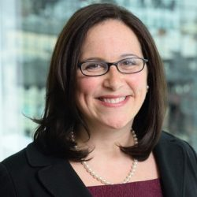

Stephanie Weiner is a partner at Harris, Wiltshire & Grannis LLP. Her practice focuses on telecommunications, Internet, and energy regulation before the courts, federal and state agencies, Congress, and the Administration.
Ms. Weiner has served in several senior positions at the Federal Communications Commission and the Department of Energy. Until 2016, she served as the Senior Legal Advisor to the FCC Chairman, overseeing all FCC matters relating to broadband competition and deployment, including net neutrality, network privacy, universal service, and major wireline transactions. Prior to joining the Chairman’s office, she was Associate General Counsel and Special Advisor to the Chairman on Internet Law and Policy. Ms. Weiner also served for two years as the Senior Legal Advisor to the General Counsel of the U.S. Department of Energy. There, she oversaw and managed the creation of a program to comprehensively enforce DOE’s energy efficiency regulations covering the import and sale of appliances, consumer electronics, lighting and other products in the United States.
Ms. Weiner previously served as Deputy General Counsel at Neustar, Inc. and as an Attorney-Advisor in the Commission’s Wireline Competition Bureau. She began her legal career as a law clerk to Judge David Tatel of the U.S. Court of Appeals for the D. C. Circuit and Judge Milton Shadur of the U.S. District Court for the Northern District of Illinois.
Ms. Weiner, who serves on the Executive Committee of the Federal Communications Bar Association, has been recognized as one of DCA Live’s Emerging Women Leaders in Law and by The Legal 500 as one of the next generation of leaders in U.S. telecom law. She graduated magna cum laude from Northwestern University School of Law, where she received the John Paul Stevens Prize for Academic Excellence. She has a Master’s Degree in Public Policy from the University of Chicago, and a Bachelor of Arts from Brown University.

Race and Diversity in Communications Law
Caitlin Carlson - University of Seattle - Communications Department


Caitlin Ring Carlson, Ph.D., is an Associate Professor in the Communication Department at Seattle University. Her research focuses on media law, policy, and ethics from a feminist perspective. Dr. Carlson has been published in leading academic journals such as Communication Law & Policy, the Journal of Media Ethics, First Amendment Studies, and the Journal of Media Law & Ethics. Her first book, “Hate Speech,” will be published by MIT Press in 2021.

Ari Fitzgerald - Hogan Lovells LLP


Ari Fitzgerald leads Hogan Lovells LLP’s Communications, Internet, and Media practice. He provides strategic, legal, and policy advice on a wide range of communications and spectrum policy issues to some of the world's largest and most dynamic communications network operators and equipment manufacturers, as well as industry trade associations and investors. Ari enjoys helping automobile manufacturers and suppliers, medical device manufacturers, and other technology companies bring new and innovative communications-related products and services to market. Ari had a distinguished career in government before joining the firm as a partner in 2001. He was a legal adviser to former FCC Chairman Bill Kennard, as well as Deputy Chief of the FCC's International Bureau. He also worked as a legal adviser in the U.S. Department of Justice's Office of Legal Counsel, where he advised the White House, executive branch agencies, and the U.S. attorney general on constitutional and federal statutory
interpretation matters.

Catherine J.K. Sandoval - Santa Clara University
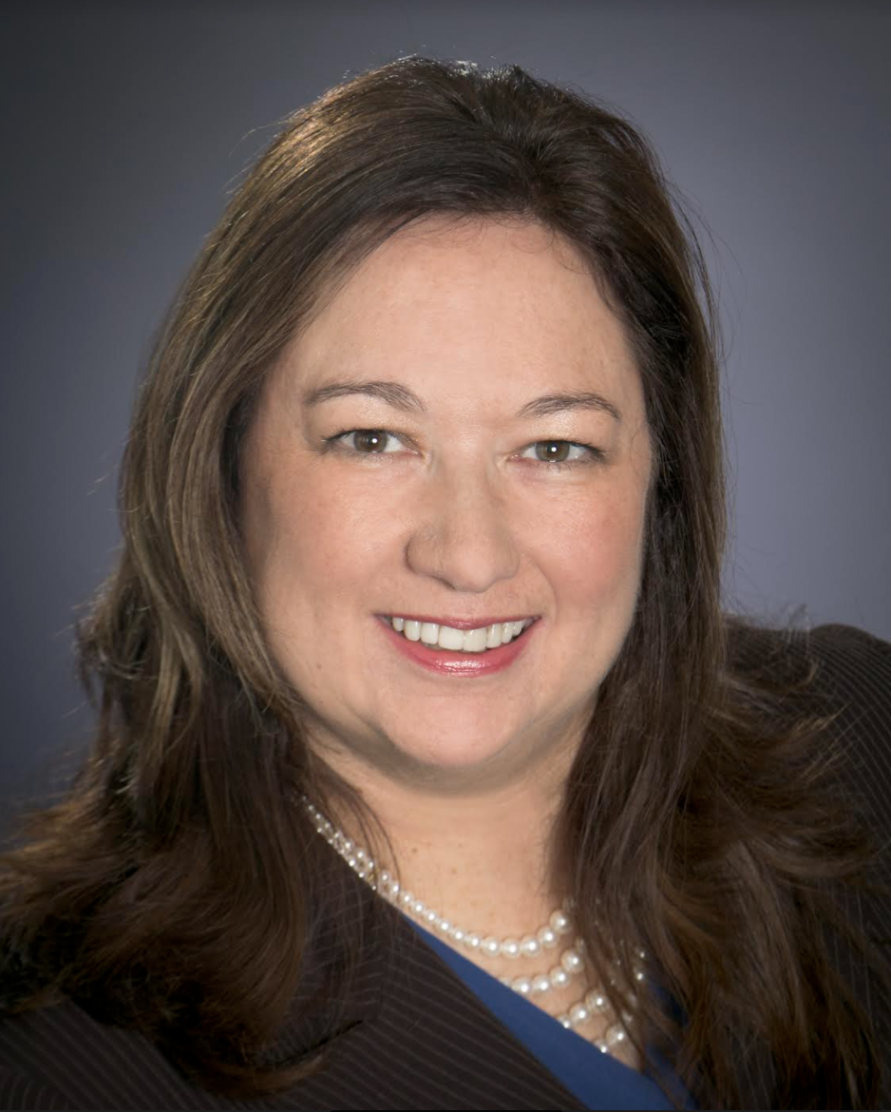

Catherine J.K. Sandoval is a tenured Law Professor at Santa Clara University who teaches and conducts research on Communications, Energy, Antitrust, and Contract law. Her scholarship analyzes legal and policy drivers of energy, communications, and water infrastructure safety, reliability, access, and equity gaps. She served a six-year term as a Commissioner of the California Public Utilities Commission, appointed by Governor Brown. THE NEW YORK TIMES, THE WALL ST. JOURNAL, THE LOS ANGELES TIMES, THE SAN FRANCISCO CHRONICLE, THE SAN JOSE MERCURY NEWS and many other publications have cited her regulatory, infrastructure, communications and antitrust law expertise. The D.C. Circuit’s 2019 Mozilla v. FCC decision cited Professor Sandoval’s comments to remand the Federal Communications Commission’s net neutrality repeal for failure to analyze the link between net neutrality and public safety. Professor Sandoval hails from a trailer park in East Los Angeles and became first in her family to earn a B.A. degree. She was the first Latina selected as a Rhodes Scholar, the first tenured Latina Law Professor at SCU Law, and the first Latinx CPUC Commissioner. She earned a B.A. from Yale University, a Master of Letters from Oxford University, and a J.D. from Stanford Law School.

Christopher Terry - University of Minnesota - Hubbard School of Journalism


Christopher Terry received his Ph.D. from UW-Madison in 2012. He spent 15 years in broadcast radio, and his research includes policy, regulatory and legal analysis of media ownership, media content and political advertising. He has published articles in a variety of journals and has been a frequent conference presenter. Terry served for six years as a lecturer at the University of Wisconsin-Milwaukee before becoming an assistant professor of Media Law at the University of Minnesota’s Hubbard School of Journalism and Mass Communication. His research has earned top paper awards from the Communication and Law Division of the National Communication Association (NCA), the Law and Policy Division of the International Communication Association (ICA), and has received financial support from both the Industry Research Forum of AEJMC and the Center for Information Policy Research.

Moderator: Ruthanne M. Deustch - Deutsch Hunt PLLC

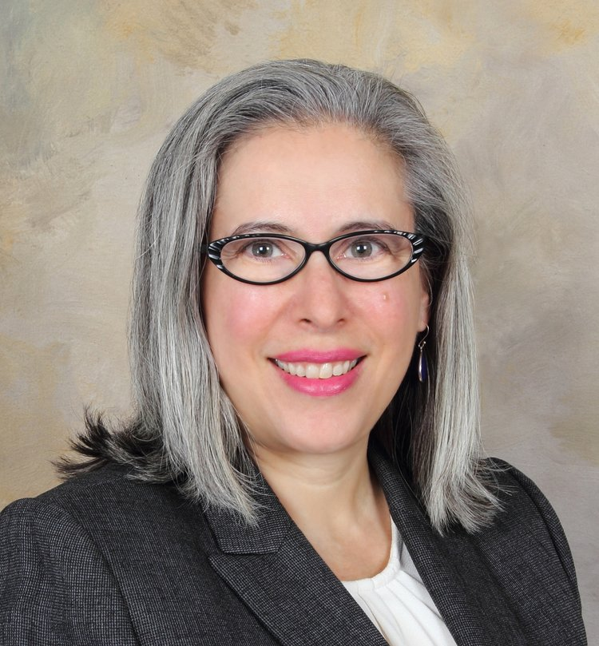
Ruthanne has briefed scores of appeals in the federal courts of appeal and state courts of last resort, including dozens of briefs at the merits and certiorari stages in the Supreme Court of the United States. She has argued before the Supreme Court, twice before the Fourth Circuit Court of Appeals, and before the D.C. Circuit and the Eleventh Circuit. She has also argued before the Maryland Court of Appeals (on a question certified by the Fourth Circuit). In addition to her work on merits and amicus briefing, Ruthanne has considerable experience litigating complex procedural and dispositive motions before various courts of appeals. She frequently counsels clients on appellate strategy before complaints are even filed, on forum selection, claim crafting, and preservation of appellate issues; and has also provided post-judgment counseling.
Ruthanne served as a law clerk for Justice Ruth Bader Ginsburg of the Supreme Court of the United States, and for Judge Timothy B. Dyk, of the Federal Circuit Court of Appeals. Immediately before co-founding Deutsch Hunt PLLC, she served as a Clinical Teaching Fellow and Supervising Attorney at the Appellate Litigation Clinic and Adjunct Professor of Law at Georgetown University Law Center, where she supervised briefing, argued cases, regularly participated in moot courts, taught a seminar for judicial interns, and co-taught appellate advocacy and federal practice. She maintains her connection to the Law Center through pro bono collaboration with the Appellate Litigation Clinic, participation in moot courts at Georgetown's Supreme Court Institute, and facilitating mindfulness training for law students in the Law Center’s Lawyers in Balance program.

Institutional Design and the Federal Communications Commission

Daniel Deacon - University of Michigan Law School


Professor ​Daniel Deacon's interests include administrative law, communications law, property, and civil procedure. His work has appeared in journals such as the Yale Law Journal, Columbia Law Review, Virginia Law Review, and NYU Law Review. He has written about executive enforcement discretion, processes for deregulation, agency regulation of arbitration agreements, and the history and future of communications and Internet regulation. Professor Deacon previously taught at the University of California, Irvine, School of Law and Harvard Law School. He practiced law at Jones Day and Wilmer Cutler Pickering Hale and Dorr LLP, where he handled matters involving telecommunications and Internet regulation, data-breach response, bankruptcy, and other areas. He has extensive experience representing clients before the Federal Communications Commission and at all three levels of the federal judiciary.
Professor Deacon received his JD, summa cum laude, from New York University School of Law. Following graduation, he was a summer law intern at the U.S. Office of the Solicitor General and then clerked for The Hon. A. Raymond Randolph of the U.S. Court of Appeals for the District of Columbia Circuit.

Jennifer Huddleston - American Action Forum



Jennifer’s research focuses on the intersection of emerging technology and law. Her work has appeared in a wide range of outlets including USA Today, the Chicago Tribune, Business Insider, Slate, the New York Daily News, and The Hill. Jennifer has appeared on media outlets including CNBC and Fox Business to discuss technology–related issues. She has also testified before Congress and state legislatures, and has been a regular panelist on issues such as transportation innovation, data privacy, and liability for content on online platforms including Section 230.
Jennifer has a JD from the University of Alabama School of Law and a BA in political science from Wellesley College. Prior to joining AAF, Jennifer was a research fellow at the Mercatus Center.
Olivier Sylvain - Fordham University Law School

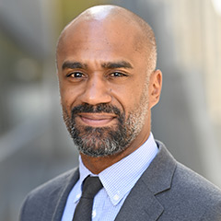

Olivier is a Professor of Law at Fordham University. His research is in communications law and policy. His most recent popular writing, scholarship, and public speaking engagements are on liability under the Communications Decency Act and the social impacts of artificial intelligence. A few months ago, the John S. and James L. Knight Foundation awarded him a grant to support this work. He is a principal investigator, along with a team of telecommunications network engineers and social scientists, in an interdisciplinary National Science Foundation grant project that is prototyping a community-administered computing network in West Harlem.
Olivier teaches Legislation & Regulation, Administrative Law, Information Law, U.S. Data Protection Law & Privacy, and information law related courses. At Fordham, he also is the Director of the McGannon Center for Communications Research, the Academic Director of the Center for Law and Information Policy, and a research affiliate at the Center on Race, Law, and Justice. Before entering academia, Olivier was a Karpatkin Fellow in the National Legal Office of the American Civil Liberties Union in New York City and a litigation associate at Jenner & Block, LLC, in Washington, D.C. He is the Board President of the New York affiliate of the ACLU and sits on the Academic Advisory Board for the Open Markets Institute and the Advisory Committee for the Cyber Civil Rights Initiative. Before the COVID-19 outbreak, he taught a class on modern American literature for local incarcerated men.

Moderator: Tawanna Lee - Wiley Rein LLP (& Former Editor-in-Chief, FCLJ)

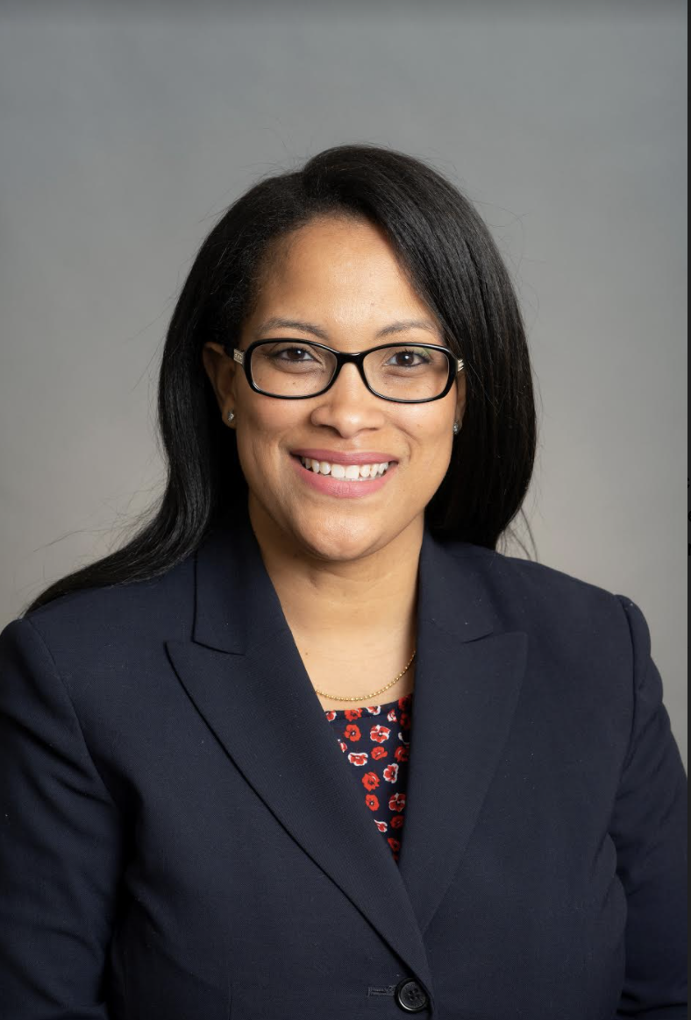

Tawanna provides regulatory counsel for Wiley Rein LLP on various privacy, telecommunications, media, and technology matters. Tawanna assists clients in developing strategy for and preparing comments, petitions, and other pleadings in proceedings before the Federal Communications Commission (FCC), the National Institute of Standards and Technology (NIST), and other state and federal agencies.

Political Economy of Telecommunications Regulation

Stuart Minor Benjamin - Duke University Law School

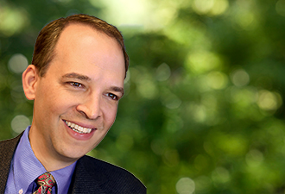

Stuart Benjamin is the Douglas B. Maggs Professor of Law and co-director of the Center for Innovation Policy at Duke Law School. He specializes in telecommunications law, the First Amendment, and administrative law. From 2009 to 2011, he was the first Distinguished Scholar at the Federal Communications Commission.
Benjamin is a coauthor of Internet and Telecommunication Regulation (2019) and Telecommunications Law and Policy (multiple editions), and has written numerous law review articles. He has testified before House and Senate committees as a legal expert on a range of topics.
From 2001 to 2003 he was the Rex G. & Edna Baker Professor in Constitutional Law at the University of Texas School of Law, and from 1997 to 2001 he was an associate professor of law at the University of San Diego School of Law.
Before he began teaching law, Benjamin clerked for Judge William C. Canby of the United States Court of Appeals for the Ninth Circuit and for Supreme Court Justice David H. Souter; worked as an attorney-advisor in the Office of Legal Counsel in the U.S. Department of Justice; worked as an associate with Professor Laurence Tribe; and served as staff attorney for the Legal Resources Centre in Port Elizabeth, South Africa. He received his B.A. and J.D. from Yale University.

Alexandrine De Bianchi - U.S. Senate, Office of Senator Jacky Rosen

Alexandrine De Bianchi is the Senior Legislative Assistant to Senator Jacky Rosen, a Member of the Senate Commerce Committee on Science, and Transportation. De Bianchi previously served as Congressional Liaison for the National Telecommunications and Information Administration, where she focused on a variety of issues including broadband deployment and mapping, spectrum, and Internet policy.

Prior to joining NTIA, Ms. De Bianchi worked in the US House of Representatives. She began her House career working as a Senior Legislative Assistant in the office of Donald M. Payne, Sr. (D-NJ) and then served as a Senior Legislative Assistant for Congressman Hank Johnson (D-GA), where she handled issues before the House Judiciary Committee including oversight of the U.S. Departments of Justice and Homeland Security, civil rights, and intellectual property. She went on to work at the Recording Industry Association of America, and also started an online macaron business.

Ms. De Bianchi attended Rochester Institute of Technology and received her Master’s at George Mason University.

Blake Reid - University of Colorado Law School



Blake E. Reid studies, teaches, and practices in the intersection of law, policy, and technology. He serves as the Director of the Samuelson-Glushko Technology Law & Policy Clinic (TLPC) and a faculty director at the Silicon Flatirons Center. Before joining Colorado Law, he was a staff attorney and graduate fellow in First Amendment and media law at the Institute for Public Representation at Georgetown Law and a law clerk for Justice Nancy E. Rice on the Colorado Supreme Court.

Christopher Yoo - University of Pennsylvania School of Law


Christopher S. Yoo is the John H. Chestnut Professor of Law, Communication, and Computer & Information Science and the Founding Director of the Center for Technology, Innovation and Competition at the University of Pennsylvania. Repeatedly recognized as one of the most cited scholars in administrative and regulatory law as well as intellectual property, he is the author of five books and over one hundred other scholarly works and has taught at over a dozen universities around the world. His major research projects include studying the economics of big data; investigating innovative ways to connect people to the Internet; analyzing the technical determinants of optimal interoperability; comparing antitrust enforcement practices in China, Europe, and the U.S.; and promoting privacy and security for autonomous vehicles, medical devices, and the Internet’s routing architecture; and studying the regulation of Internet platforms, including network neutrality. He has also created innovative joint degree programs designed to produce a new generation of professionals with advanced training in both law and engineering.

Professor Yoo received his A.B. from Harvard University, his M.B.A. from UCLA, and his J.D. from Northwestern University. He began his academic career at the Vanderbilt Law School in 1999 and joined the University of Pennsylvania faculty in 2007. Before entering the academy, Professor Yoo clerked for Justice Anthony M. Kennedy of the Supreme Court of the United States and practiced law with the predecessor firm to Hogan Lovells under the supervision of now-Chief Justice John G. Roberts, Jr. He is frequently called to testify before the U.S. Congress, Federal Trade Commission, Department of Justice Antitrust Division, Federal Communications Commission, foreign governments, and international organizations. He has also served as a non-governmental advisor to the International Competition Network and is currently serving as a member of the Federal Communication Commission’s Broadband Deployment Advisory Committee and a Consultant to the joint European Law Institute-American Law Institute project on Principles for a Data Economy.

Moderator: Natalie Roisman - Wilkinson Barker Knauer LLP (& President, Federal Communications Bar Association)

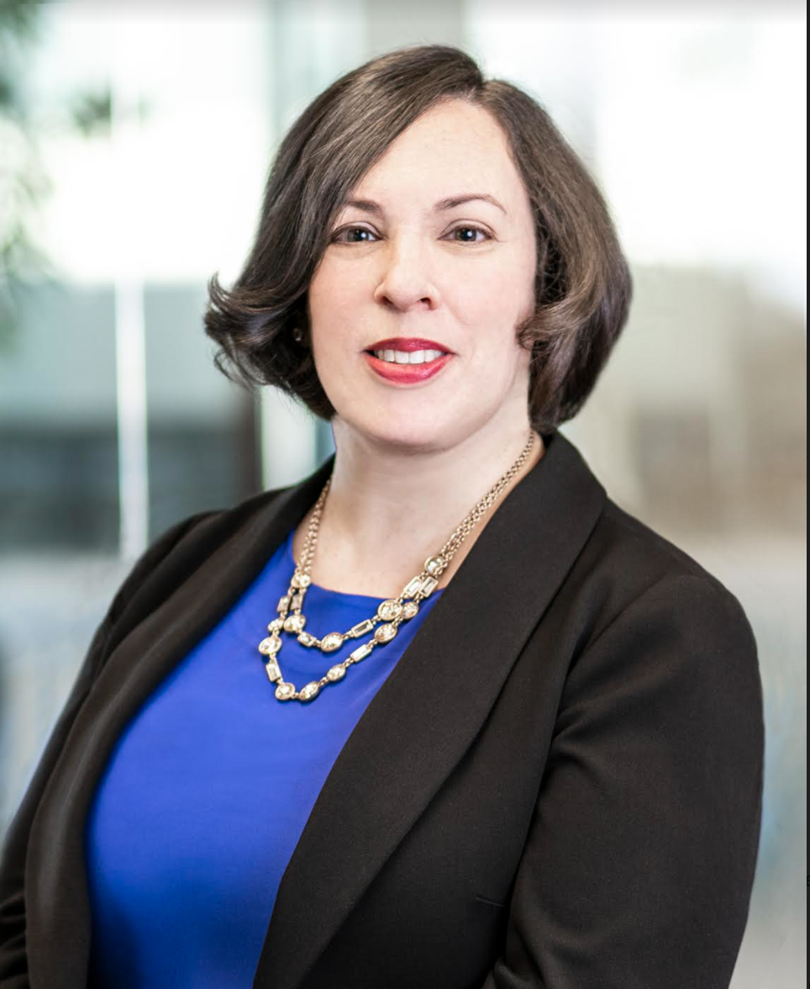

Natalie Roisman is a Partner and Director of Social Responsibility at Wilkinson Barker Knauer, LLP in Washington, D.C.

Natalie advises companies, trade associations, and investors on the impact of Congressional, Executive Branch, and federal agency policy actions in areas such as technology, media, and telecommunications regulation; consumer protection; cybersecurity; and privacy and data security. She represents clients before the FCC, FTC, Department of Commerce, and other agencies. Clients look to Natalie to develop and execute creative strategies in regulatory policy advocacy.

In her role as the firm’s Director of Social Responsibility, Natalie leads WBK’s diversity and inclusion initiatives and coordinates pro bono efforts.

Natalie currently serves as President of the Federal Communications Bar Association (FCBA – The Tech Bar) and sits on the Board of the Women’s Bar Association of D.C. She founded WBK’s Women’s Initiative and serves in a number of nonprofit and advocacy group leadership positions. Before joining WBK in 2008, Natalie worked in the federal government and at an AmLaw 100 firm. She is a graduate of the University of Chicago and the University of Pennsylvania Law School.

